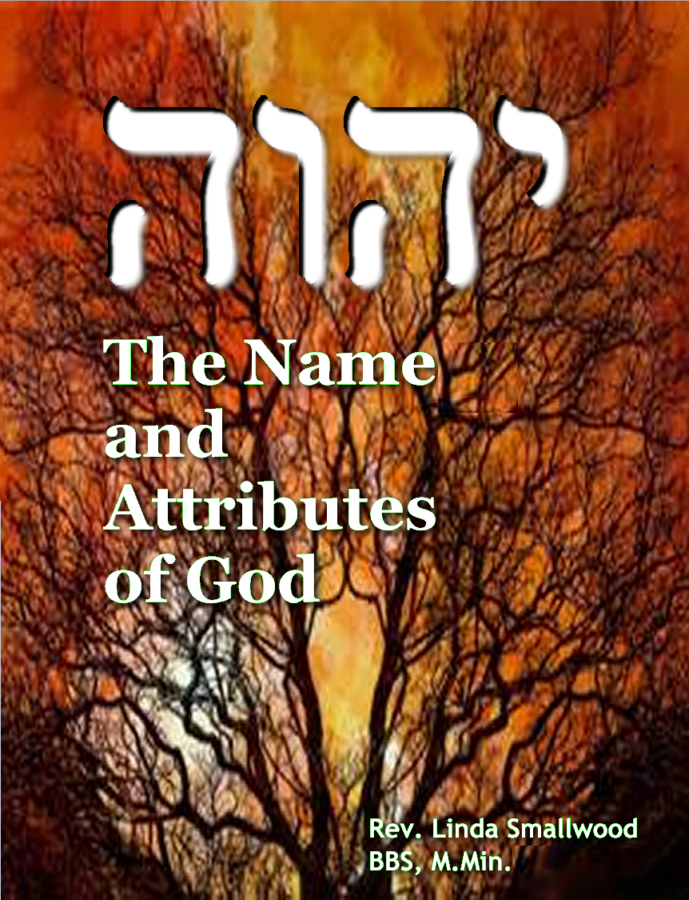



**Table of Contents**

Preface & Introduction3

Our God’s ***Name*** is Glorious and Awesome!5

Bible References to the ***Use*** of God’s Name 6

YHWH (YHVH/YHUH) / Jehovah 8

Adonai (Adonay) & Elohim / El / Eloah 11

El Shaddai 15

El Elyon (El ‘Elyon) 17

Other “El” Compound Names 18

YHWH-Jireh (Yireh) 21

YHWH-M’Kaddesh (Mekeddeshem, Mekadesh, Mekoddishkem) 23

YHWH-Nissi 25

YHWH-Rohi (Ro’i, Ro’eh) 26

YHWH-Rophe (Rapha, Rophecha, Roph’ekha) 28

YHWH-Shalom 29

YHWH-Shammah 30

YHWH-Tsid’Ke-nu (Tsidkenu, Tzidkaynu, Tsidqenuw) 31

YHWH-Tzva’ot (Sabaoth, Sabbaoth) 33

Disclaimer, Scripture References, Sources of Reference,

Reprint/Distribution Permissions, and Copyright

**Disclaimer Notice**

The name and titles God used to reveal Himself to humankind represent His power, actions, love, and reputation.

The Almighty is not an object to be possessed, nor is He subject to or dependent upon anyone. The Bible forewarns

us not to invoke the name of God for selfish or manipulative purposes. These materials are for educational purposes

only and are not intended to offer some sort of mystical insight into the Divine nature of Almighty God.

**Scripture References**

Unless otherwise noted, Bible quotations are from the online

"[World English Bible](http://www.biblestudytools.com/web/)" (WEB), which uses "Yahweh" for the name of God.

Other Bibles frequently used in this study are:

"The Scriptures" 1998 (TS98), which employ the Hebrew letters יהוה for the name of God, or the

"[Complete Jewish Bible](http://www.biblestudytools.com/cjb/)" (CJB), which normally uses the name "Adonai" for the Hebrew name of God.

**Sources of Reference**

[Behind the Name](http://www.behindthename.com/)

[BELIEVE Religious Information Source](http://mb-soft.com/believe/indexaz.html)

[Bible.org - Trustworthy Bible Study Resources](http://www.bible.org)

[Blue Letter Bible Study Tools](http://www.blueletterbible.org/index.html)

"*Crowned with Glory – The Bible from Ancient Text to Authorized Version*" by Dr. Thomas Holland

“*Elwell Evangelical Dictionary*”

[Hebrew for Christians](http://hebrew4christians.com/index.html)

"[*International Standard Bible Encyclopedia*](http://www.internationalstandardbible.com/)"

[Online Jewish Encyclopedia](http://www.jewishencyclopedia.com/)

[Judaism 101](http://www.jewfaq.org/index.htm)

[Lambert Dolphin's Library](http://www.ldolphin.org/)

[Mustard Seed Media](http://www.mustardseed.net/html/tonamesofgod.html)

"[*Nave's Topical Bible*](http://naves-topical-bible.com)"

"*Praying the Names of God*" by Anne Spangler

[Precept Ministries International](http://www.precept.org/newindex.html)

“[*Strong's Hebrew & Greek Dictionary*](http://www.htmlbible.com/sacrednamebiblecom/kjvstrongs/STRINDEX.htm)"

"*The Names of God*" by Nathan Stone

"*The Titles of Jehovah*" by H. W. Webb-Peploe

[Where's the Church?](http://www.wheres-the-church.com/)

[Wikipedia — the Free Online Encyclopedia](http://en.wikipedia.org/wiki/)

**Reprint Permissions**

Individuals and not-for-profit groups may copy any portions of these studies for use in small group Bible studies.

However, I do request that you [notify me](mailto:pastorlinda@myredeemerlives.com) and include in your publication the copyright notice shown below. If you want

to disseminate these studies via the Internet or wider print distribution, please provide details and [request permission](mailto:pastorlinda@myredeemerlives.com).

Copyright ©; 2010, 2013, 2017 "The Name & Attributes of God".

Revision of "Names of God" Bible Study, Copyright © 2007.

Rev. L. S. Smallwood. [My Redeemer Lives Christian Ministry](http://www.myredeemerlives.com)™. All rights reserved.

